- Purpose

This procedure provides policy and procedure for software design and development.

- Scope

This procedure applies to the design and development of:
- Software used as a component, part, or accessory of a medical device;
- Software that is itself a medical device :
- Software used in the production of a device (e.g., programmable logic controllers in manufacturing equipment); and
- Software used in implementation of the device manufacturer’s quality system (e.g., software that records and maintains the device history record).

This procedure is intended to be followed by all EPIC personnel who are involved with software design and development.

- Definitions

Design Validation | Establishing by objective evidence that device specifications conform to user needs and intended uses.
EPIC ClearView | The core software product that drives the EPIC system.
Non-Breaking Change | A change to the software that is purely cosmetic, not affecting any of the business or calculation logic.
Process Validation | Establishing by objective evidence that a process consistently produces a result or product meeting its predetermined specifications.
Requirements | The needs or expectations for a system and/or its software. There can be many different kinds of requirements (e.g., design, functional, implementation, interface, performance or physical requirements).
Specification | In software development, a specification is defined as a document that states the requirements
Verification | Confirmation by examination and provision of objective evidence that specified requirements have been fulfilled.
Validation | Confirmation by examination and provision of objective evidence that the particular requirements for a specific intended use can be consistently fulfilled. Also said as, confirmation by examination and provision of objective evidence that software specifications conform to use needs and intended uses, and that the particular requirements implemented through software can be consistently fulfilled.

- Responsibilities

User | - Complies with the policy and procedure for all new or revised design projects.  - Ensures the most current version of this document is used when referenced.  - Acts as project coordinator to ensure proper protocol development, accurate and timely protocol execution, and development of the final report.
Departmental Management | - Ensures departmental personnel are properly trained before using this policy or procedure.  - Assigning personnel as project manager and/or to validation team(s).  - Complies with the policy and procedure for all new or revised design projects.  - Ensures the most current version of this document is used when referenced.  - Reviews and approves protocols prior to validation and summary report of the validation activities to ensure that activities reflect actual activities performed, at a minimum.
Quality Assurance | - Complies and enforces the document control standards within this document.  - Monitors the implementation and effectiveness of this document.  - Conducts periodic audits to assure compliance.  - Reviews and approves protocols prior to validation and summary report of the validation activities to ensure that all quality system requirements are met, at a minimum.
Engineering/Manufacturing | - Provides technical and specific guidance for protocol development and validation process execution.  - Reviews and approves protocols prior to validation and summary report of the validation activities to ensure that summary report meets the technical requirements for software validation and that conclusions drawn are valid, at a minimum.

- Policy

Software development is required to follow the appropriate design control processes (reference section 7.0 below). This document is intended to provide guidance and requirements specific to software development only. These requirements are in addition to the requirements specified in the additional design control policies listed in section 7.0 below unless otherwise specified below.

- Procedure

  - Development of the Software Requirements Specification (Design Inputs)
    - New software development will begin with completing the Design Approval Form. The project will include the initial development of an Input/Output Matrix form documenting the high level inputs to software development.
    - All requests for changes to existing software must be entered into the bug/enhancement tracking system ‘Gemini’. Gemini is a third party product provided by CounterSoft that runs as an application on EPIC’s intranet.

Gemini is a proven product used by companies such as:
      - CapGemini
      - Dell
      - Disney, Et al.

The Gemini system is secured through user Id and password authentication, as well as only being accessible through the intranet. If you do not have valid login credential see the EPIC IT department to get configured on the system.

When adding a request into the Gemini system, it should be filled out as completely and with as much detail as is necessary to accurately describe the problem or proposed enhancement from a user’s perspective. The more information that can be conveyed in this submission the better, so the inclusion of attachments and detailed descriptions are strongly encouraged.

The Gemini system allows for a significant collection of information, each section will be outlined below and users are strongly encouraged to complete as much of the form as possible. The likelihood that the bug or enhancement will be addressed will be influenced by the quality of the requestor’s information.

The first part of the request form is shown below, this section is critical and all fields should be filled out:

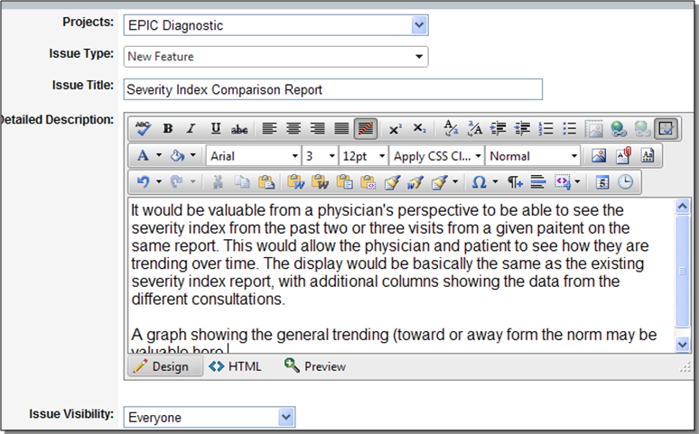

The second section of the form contains more important information pertaining to the requested change. Probably the most important is the Issue Priority. It is important to be very reflective when setting the priority of the item, NOT everything HIGH. The priority should reflect many factors such as (potential revenue or revenue loss, product perception, etc.)

The values for the following should not be set by the submitter; they will be modified in the subsequent steps as the requests are prioritized.

      - Fixed For Version
      - Assigned Resource
      - Work Estimate

The image below shows a properly filled in sample of the lower portion of the form:

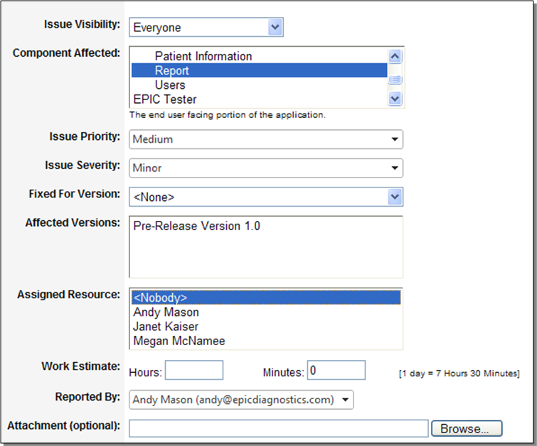

Upon submission of the issue, the submitter and the development team will be made aware of the item via email. The submitter is then required to print out the submission, sign and date the original copy and forward to Quality Assurance for filing within the Design History File.

The Gemini system can be found at the following URL: http://Arizona5/Gemini

    - Once a development cycle, product management and development will meet to discuss and prioritize the issues that appear in Gemini. Once this process is complete, a subset of these issues will be selected and placed into a new work unit which will comprise the next release of the software. This process will involve comparing the item in Gemini to the current market and client base condition to determine the true priority of the fix or enhancement. It will also involve the development team providing very high level estimates of the effort that will be required in order to implement the change. The combination of these data points will provide the information necessary to make a decision as to when (if at all) to perform the work.

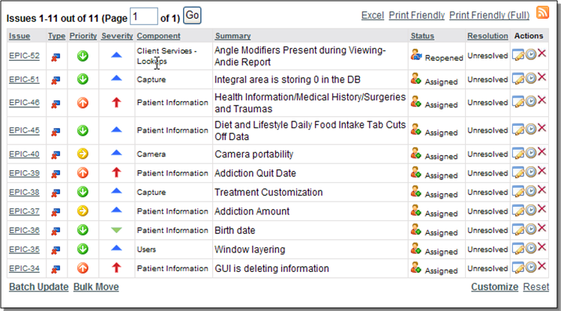

    - After the release has been loosely defined, the development team will work with product management to create the requirements specification. Again this should simply be an enhancement of the information entered into Gemini. The requirements document can then be attached directly to the Gemini item.

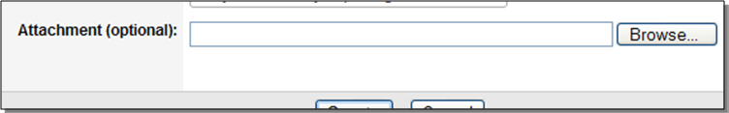

The software requirements specification should follow the guidance provided in the Design Input Requirements procedure and should clearly identify functional requirements of the design that will allow the software to meet the user needs. The requirements specification should include an executive summary.

  - Software Design and Development Planning
Working with the items that have been designated into the release in Gemini, the development team will create the necessary design documents and information required to build the requested functionality.

Every attempt will be made to use existing components and algorithms. If any external components are required to create the new functionality, they will be documented and researched before acquisition.

Any change to the Gemini system (adding documentation, etc.) will be documented in the Design History File. The submitter is required to print out the Gemini submission, sign and date the original copy and forward to Quality Assurance for filing within the Design History File. Any documents attached to the Gemini record will be printed in hard copy and filed with the Gemini submission in the Design History File.

  - Software Authoring
Source code control. All required source files for the application are stored in a Source Code Control System (SCCS) called Perforce. Perforce is an internationally recognized company and is used by many of the largest companies in the world such as:

- Electronic Arts
- Cisco Systems
- MCI
- GE Healthcare

Perforce is secured by ID/Password authentication, if you do not have the valid credentials, check with EPIC IT.

All source code should be checked out to the local development machine before changes to the code begin.

Before beginning to work on a task from Gemini, the status of the task should be changed from Assigned to In Progress. The developer is then required to print out the submission, sign and date the original copy and forward to Quality Assurance for filing within the Design History File.

All software should be developed in Visual Studio using C# as the development language. All best practice coding standards should be followed as well as any specific standards specified by the EPIC IT department.

Unit testing – All software developers should be unit testing their changes locally as is appropriate. It is imperative that only fully unit tested changes be committed to the SCCS system. Follow the Software Development Verification Testing Procedure to document all verification testing including unit testing.

Check in – Once the code is complete and it has been satisfactorily unit tested, it can be checked back into the SCCS. During check in, a description of the change must be entered. The description should include the following:

- The Gemini tracking number that the code change addresses (EPIC-54)
- A description of the code change that was made (shot and simple).

The status of the Gemini item should then be changed to ‘Complete’ which would indicate to the QA department that it is ready for testing. The developer is then required to print out the submission, sign and date the original copy and forward to Quality Assurance for filing within the Design History File.

All validation testing of completed software development (imitated as changes and new product development) will be conducted and documented according to the requirements specified in the Software Validation SOP. Software changes and/or new development are not released until all quality system requirements are met.

- Reference

EG-001, Design Control Policy
EG-002, Design and Development Planning
EG-003, Design Input Requirements
EG-011, Software Validation
EG-016, Software Development Verification Testing Procedure
EGF-001, Design Approval Form
EGF-002, Design Input and Output Matrix
21 CFR Part 11, Electronic Records: Electronic Signature

- Attachments

N/A

Document Revision History
Change Order Number: | Version Number: | Description of Change: | Date: | Updated by:
CC-011810-01 | 000 | New Document | 1/26/10 | AFM
CC-120202-01 | 001 | Update section 6.3.4 to refer to the Software Development Verification testing Procedure. | 2/3/12 | A. Mason
CC-120208-01 | 002 | Add 21 CFR Part 11 to the reference documents. | 2/28/12 | A. Mason

